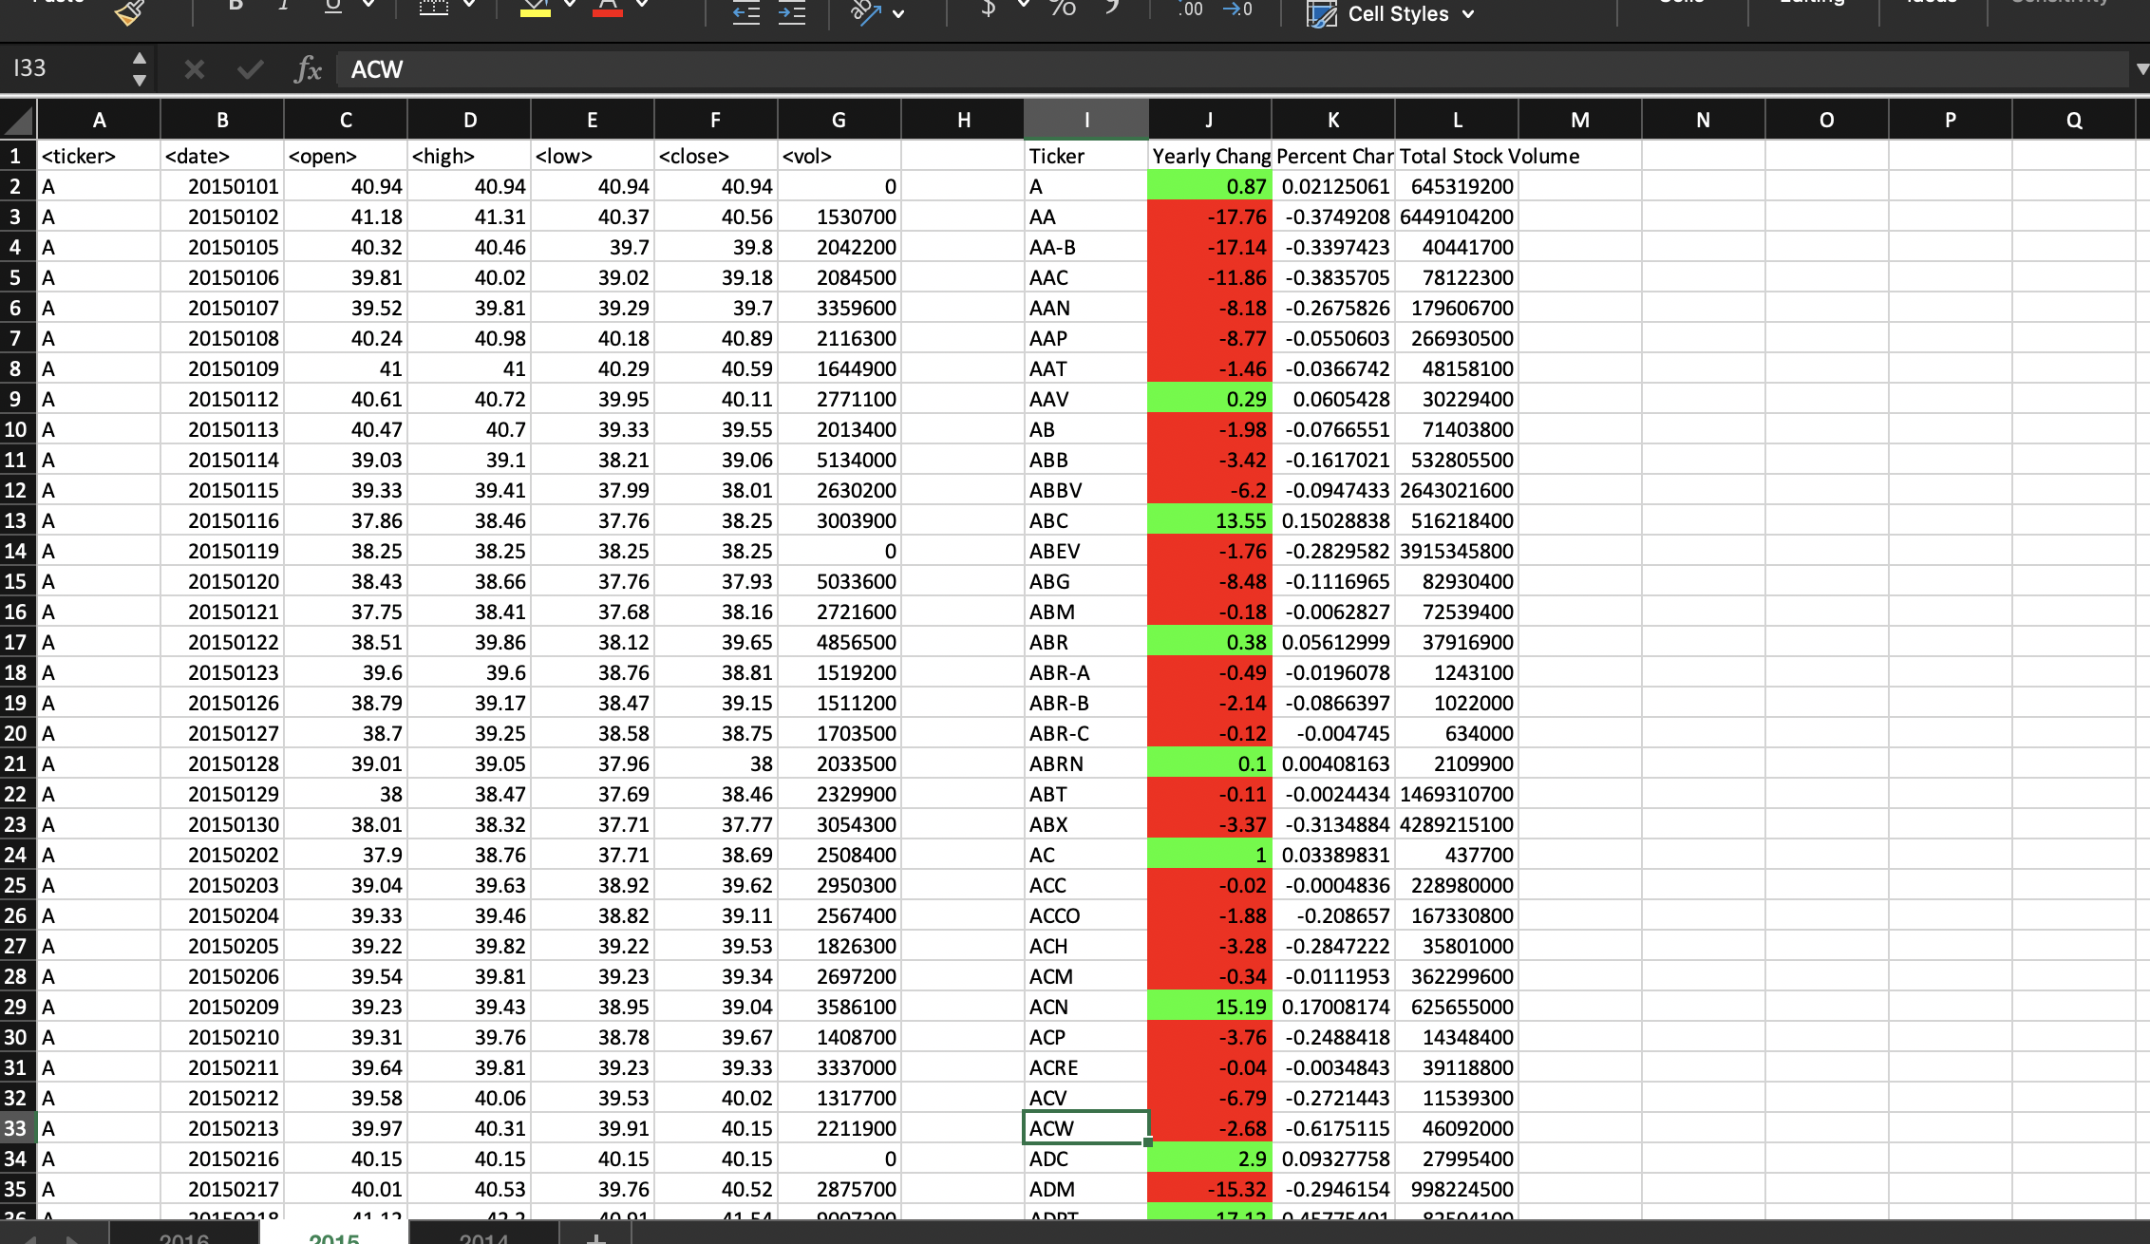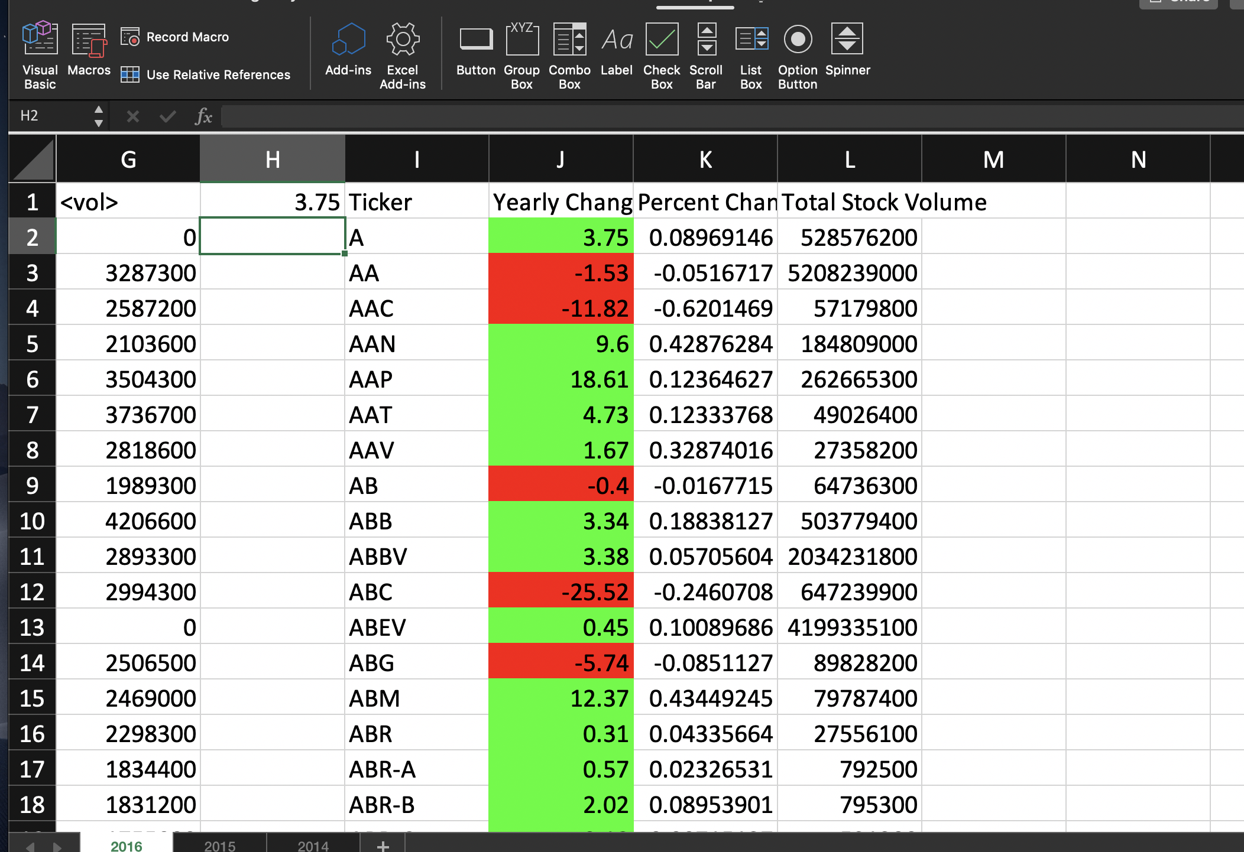Option Explicit

Sub vba_homework()

' Double: 1.2

' Integer: 1

' Long: is an integer that's long

Dim ticker As String

Dim price_change As Double

Dim percent_change As Double

Dim stock_vol As Double

Dim last_row As Double

Dim start As Long

Dim difference As Double

Dim i As Long

Dim j As Integer

Dim ws As Worksheet

Dim open_price As Double

Dim close_price As Double

Dim volume As Double

Dim startprice As Double

'to help it not crash

Application.ScreenUpdating = False

For Each ws In Worksheets:

'labels

ws.Range("I1").Value = "Ticker"

ws.Range("J1").Value = "Yearly Change"

ws.Range("K1").Value = "Percent Change"

ws.Range("L1").Value = "Total Stock Volume"

stock_vol = 0

'to keep track of where to start open prices

start = 2

'to keep track of new chart created with solutions

j = 2

last_row = ws.Cells(Rows.Count, 1).End(xlUp).Row

'looping

For i = 2 To last_row

'to check if sticker is still the same

If ws.Cells(i, 1).Value <> ws.Cells(i + 1, 1).Value Then

' stock_vol calculation

stock_volume = stock_vol + ws.Cells(i, 7).Value

' end of ticker calculations

ticker = ws.Cells(i, 1).Value

ws.Cells(j, 9).Value = ticker

ws.Cells(j, 12).Value = stock_vol

open_price = ws.Cells(start, 3).Value

close_price = ws.Cells(i, 6).Value

difference = close_price - open_price

'color in yearly price change column

If difference < 0 Then

ws.Range("J" & j).Interior.ColorIndex = 3

Else

ws.Range("J" & j).Interior.ColorIndex = 4

End If

ws.Range("J" & j).Value = difference

'to avoid dividing by zero

If open_price = 0 Then

open_price = 1

End If

ws.Range("K" & j).Value = difference / open_price

' adjust variables for next ticker

start = i + 1

stock_vol = 0

j = j + 1

Else

' stock_vol calculation

stock_volume = stock_volume + ws.Cells(i, 7).Value

End If

Next i

Next ws

'to help it not crash

Application.ScreenUpdating = True

End Sub